NWOFI
Northwestern Oregon Facilitation Initiative
Family Law Facilitators are available by phone or video

9:00 AM – 12:00 PM
1:00 PM – 4:00 PM
Monday through Friday
Pacific Time
503-434-3040
Need an appointment?
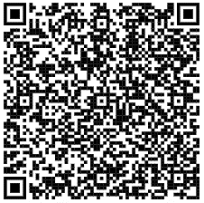
Book an appointment online or call us today
For more information, visit:
www.courts.oregon.gov/
services/online/pages/nwofi.aspx

Clatsop Columbia
503-325-8555 503-397-2327
Ext. 23123 Ext. 24025

Lincoln Polk
541-265-4236 503-623-3154
Ext. 41014 Ext. 48010

Tillamook Yamhill
503-842-2596 503-434-7530

Ext. 70089 Ext. 70536

Washington
Protective Orders: 503-846-2857
Facilitators: wsh.familylaw@ojd.state.or.us

Interpreters available upon request

LOCAL COURT FACILITATORS



